Fulton Pulse Air Flapper Maintenance
Before disassembly of the air flapper assembly, it is important to know your starting point. This point is the last point that the air flapper was set when your unit had clean, whole gaskets and combustion was set properly. The most accurate way to determine your starting point is to do as follows.
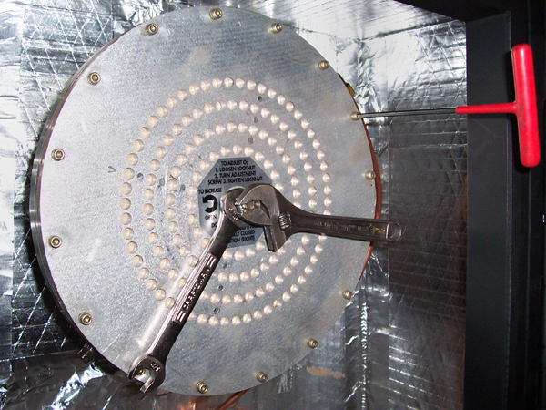
Obtain a small crescent wrench and a 9/16" open-ended wrench. Apply your crescent wrench to the center adjustment screw on the air flapper assembly. Note that the end of the crescent wrench is close to being directly over one of the 16 allen headed screws holding the air flapper assembly to the air flapper housing. Hold the crescent wrench in place while the 9/16" lock nut is loosened at least three full turns. Using the 16 allen screws at the perimeter of the air flapper assembly, count incrementally the number of screws the end of the crescent wrench passes over as you fully close the air flapper valve. For example, 1 full revolution would equal 16 screws. This method of determining starting point is more accurate than estimating full revolutions or guessing blindly.
After air flapper valve is fully closed and the number of screws passed over is noted, remove the air flapper assembly from the air flapper housing by removing the 16 9/64" allen headed screws form the perimeter of the assembly.
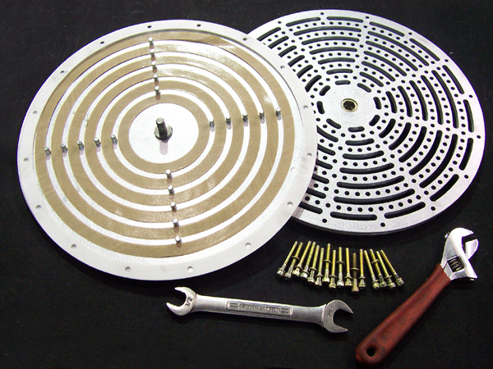
Now the assembly can be taken apart. Loosen the center adjustment screw until assembly comes apart. At this point, the air flapper assembly plates, gaskets and outer perimeter spacer will be exposed for cleaning or replacing. Clean with a damp cloth or light cleaning solution only. Do not use any abrasive materials or tools to clean. (Before cleaning, note which side of gasket is dirty. Upstream dirt can represent a problem with the air supply and may suggest more frequent inspection/cleaning. Downstream fouling can represent poor combustion.) Torn or frayed gaskets should be replaced. After gaskets have been cleaned or replaced, reassemble air flapper assembly. Make sure that the through holes of both the front and back plate of the assembly as well as the outer perimeter spacer line up.
When assembly is put back together, re-attach it to the air flapper housing. Start all allen headed screws before tightening.
After assembly is installed, begin to reset the gap between the plates of the air flapper assembly by applying your crescent wrench to the center adjusting screw. Start with the valve fully closed. Note the position of the end of the crescent wrench and turn open the air flapper valve to the number of increments noted earlier. Tighten down lock nut. This point is the same point that the unit was last set.
Note: It is always better to test and adjust combustion by use of a combustion analyzer. The setting above should allow the unit to operate, but does not necessarily guarantee optimum combustion efficiency.

